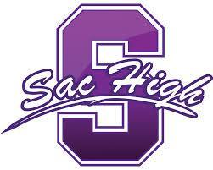

Sacramento High School
Service to Others

School Site Council Meeting
January 9, 2017
Room W9
4:00 – 5:00pm

AGENDA

Agenda Item Presenter Action Time

- Call to Order/Roll Call F. Lawrence Information 4:00

- Approve the Agenda and Minutes F. Lawrence Action 4:05

- Public Comment Information 4:10

- Update on Staffing M. Seijas Information 4:20
  - Hires
  - Openings

- Early Academic Opportunity Program , UC Davis L. Fuller Information 4:35

- Future Agenda Items Information 4:55

- Adjourn F. Lawrence Action 5:00

NEXT MEETING: Monday, February 6, 2017
4 – 5pm, Room W9
Presentation by City Year

