Join the Black United Fund of Sacramento Valley
and
the Sacramento Area Black Caucus
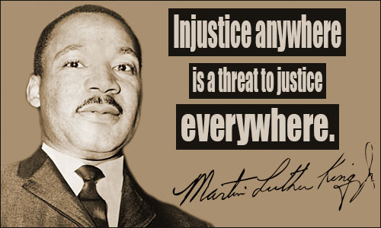
For the
9th Annual Martin Luther King, Jr. Day of Service
On Sunday, January 21, 2018, from 1 pm--3 pm
At the Office of
The Black United Fund,
4104 44th Street, Sacramento CA. 95820
We are collecting unworn winter clothing including items such as: hats, gloves, scarves, sweat shirts, and socks. Please bring your donation and join us on Sunday, January 21 at 1:00pm, when we will assemble packages of new, unworn winter clothing for children and adults. These packages will be distributed to local homeless shelters. Also, this year, we will be collecting warm blankets to distribute along with the clothing.
Please RSVP by January 14 or for more info please contact:
916 484-3750/fayek@springmail.com.

